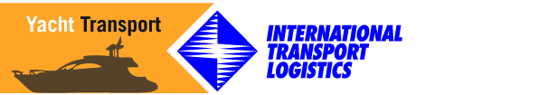

Yacht Captains, Certified

Palm Coast, Florida

Donald Kull
USCG Licensed Master
Phone: 386 931 3977
captdkull@gmail.com

James McIntyre
USCG Licensed
Phone: 386 931 2506
jkmack@bellsouth.net

Pat Slattery
USCG Licensed Master
Captpatslat@aol.com

Panama City, Florida

Capt. Ric Corley
Phone: (850) 527-5287
www.captcorleyandson.com

